JNS0501000000273

Score
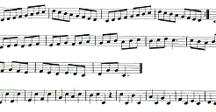
JNS0501000000

