JNS0501000000281

fScore
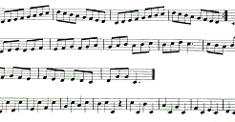
f

